DEVELOPING WEB APPLICATION USING NODE- RED SERVICE

|  |  |
| --- | --- |
| **Team ID** | **PNT2022TMID40963** |
| **Project Name** | **IoT Based Smart Crop Protection System For Agriculture** |

**Step 1:**Click on your Node-Red flow editor where you will be redirected to the Node-Red flow editor.

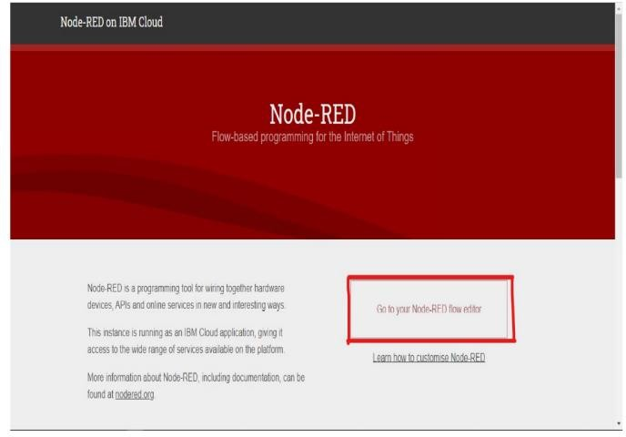

**Step 2:**To install IBM nodes in Node-Red flow editor click on manage palette in the new menu option which is on the top right on the screen.

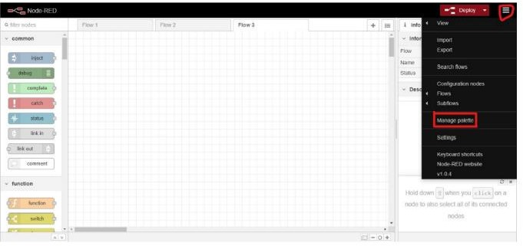

**Step 3:**In Install section search for ibmiot and install the ibm nodes to the flow editor.

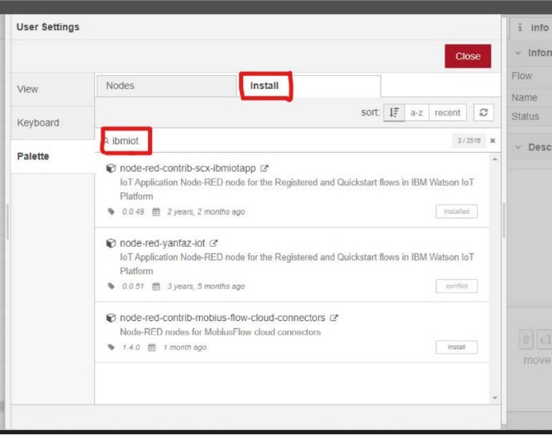

**Step 4:**Search for IBM nodes in the filter nodes section.

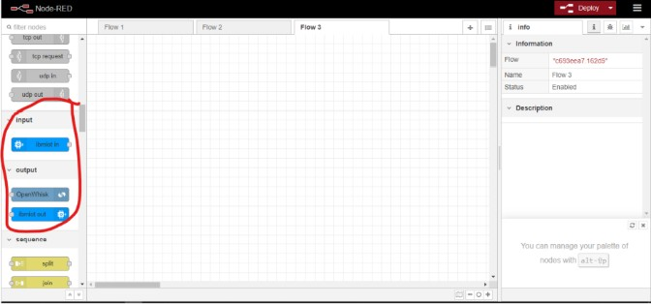

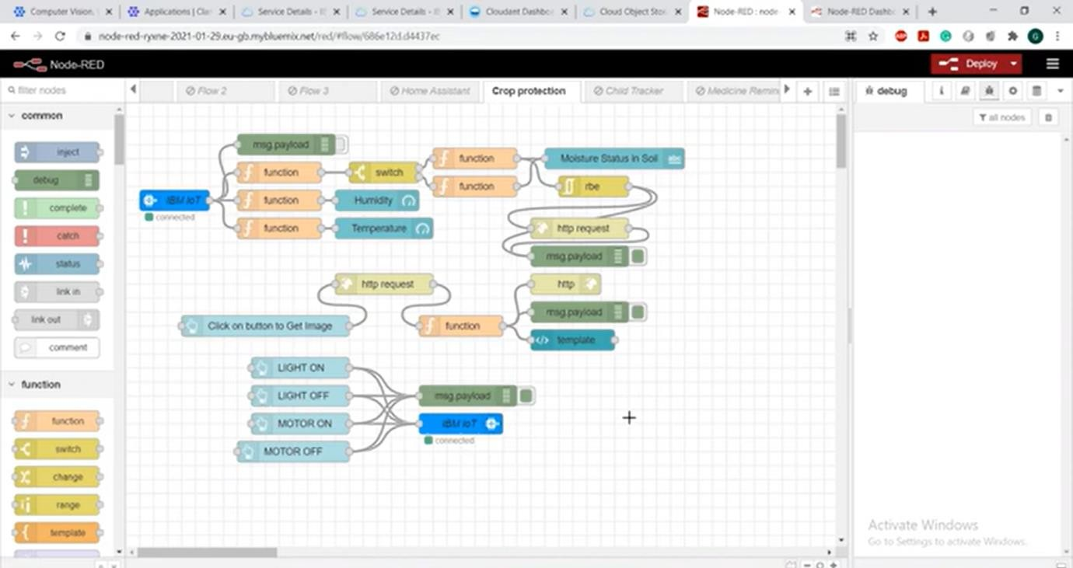

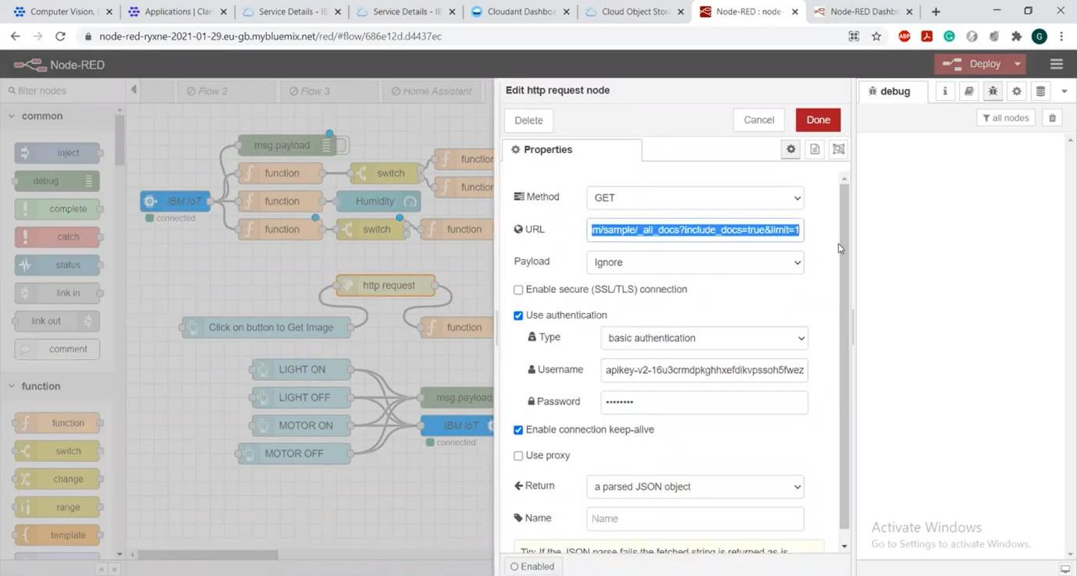

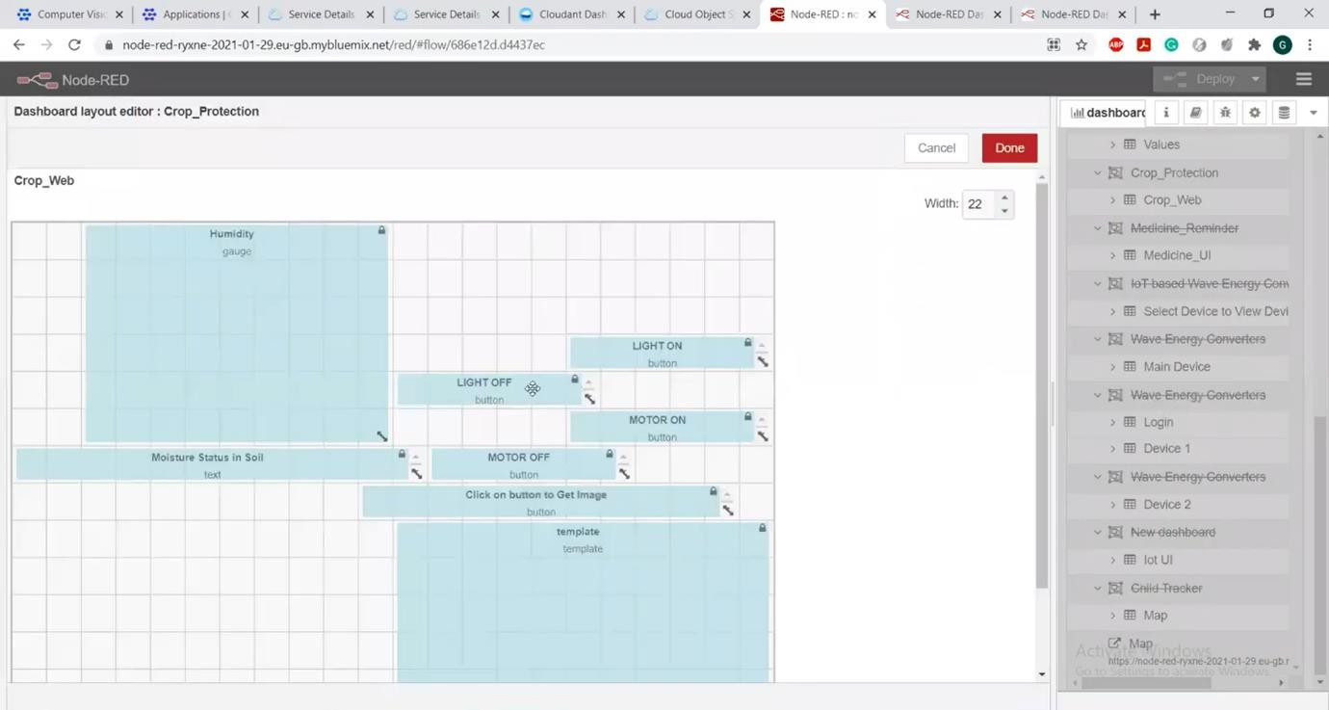

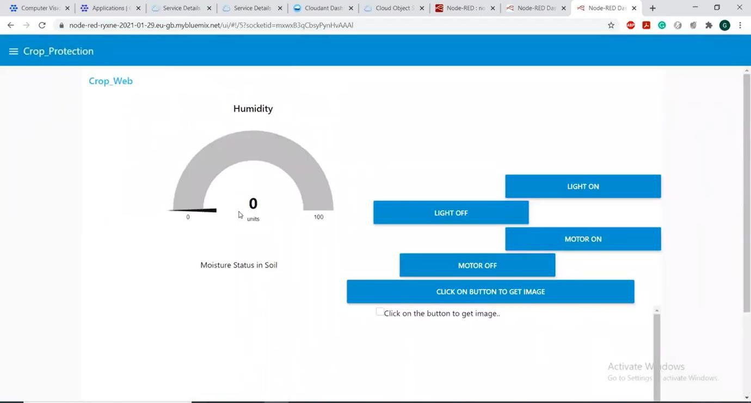

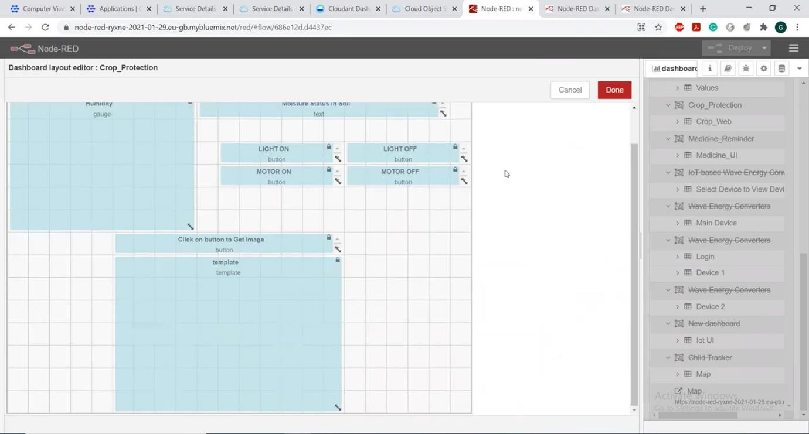

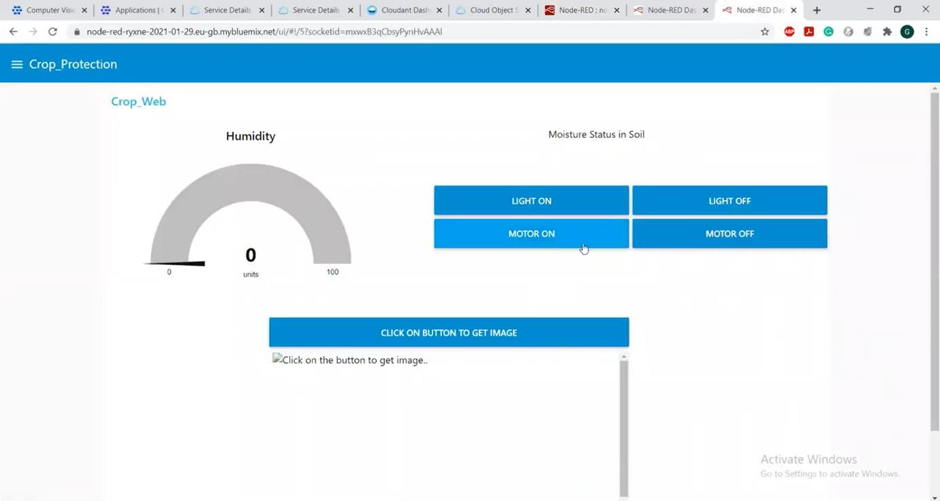

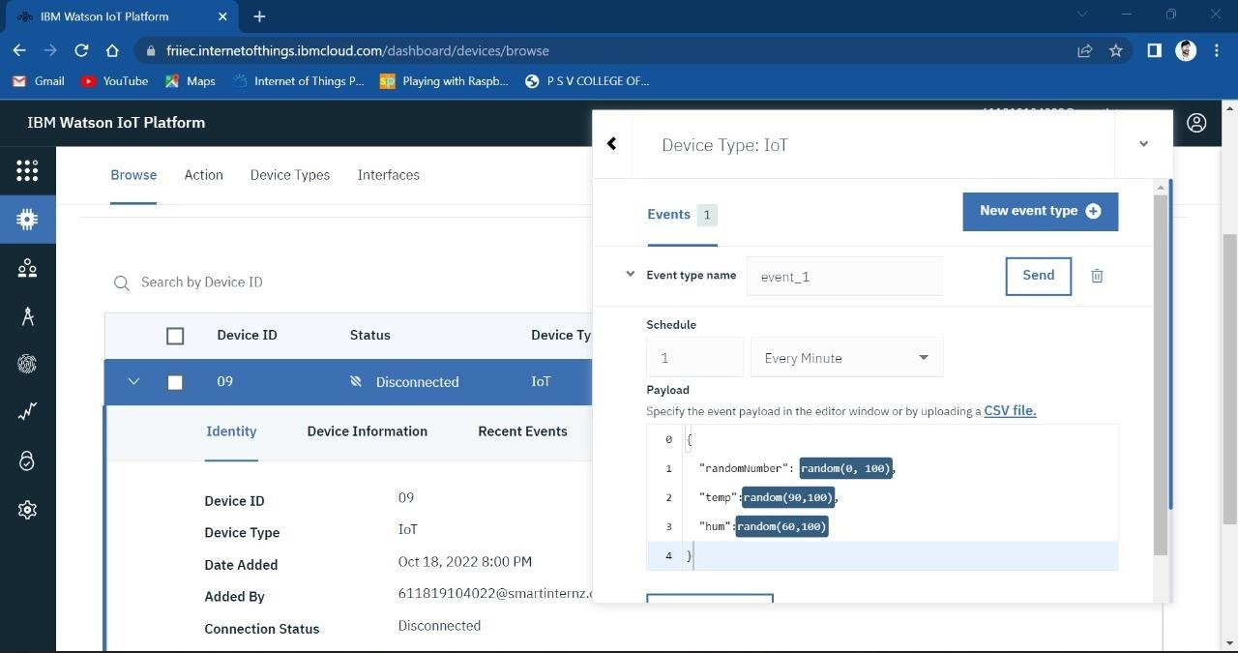

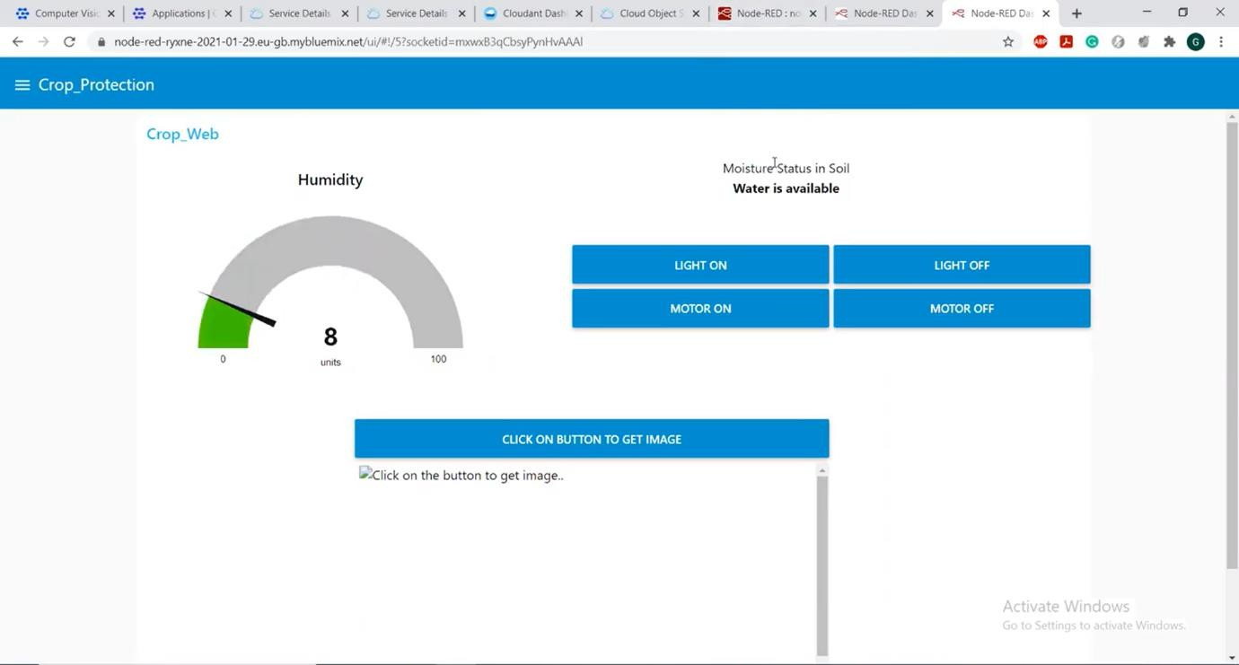

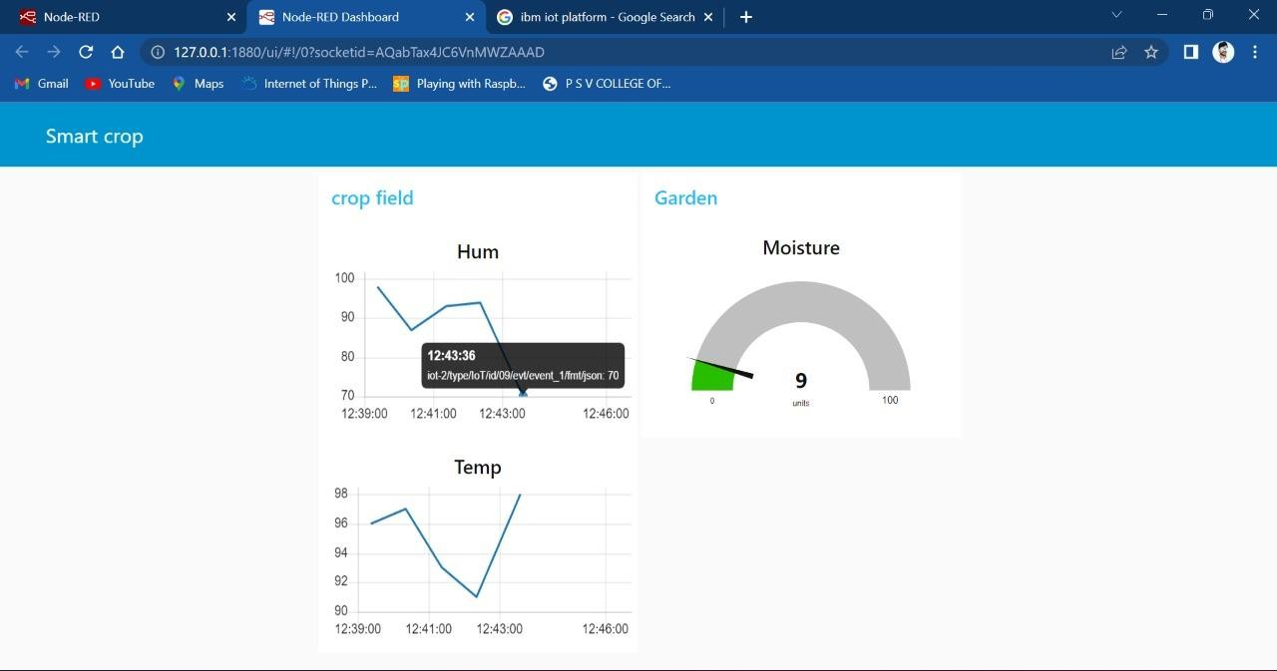

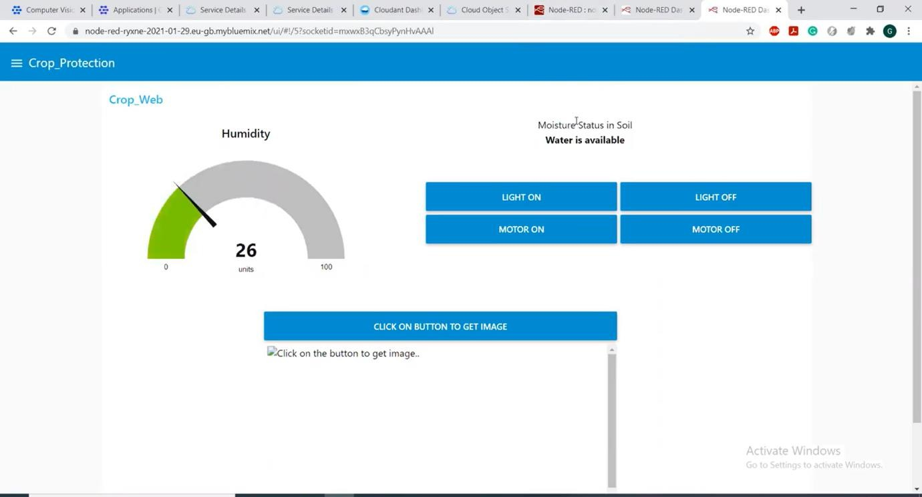

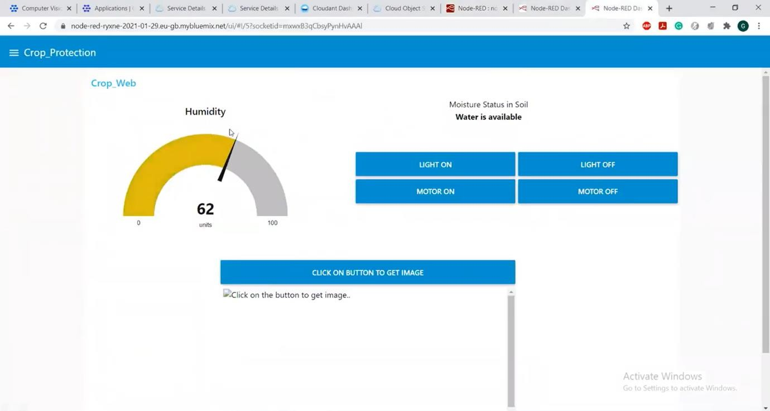

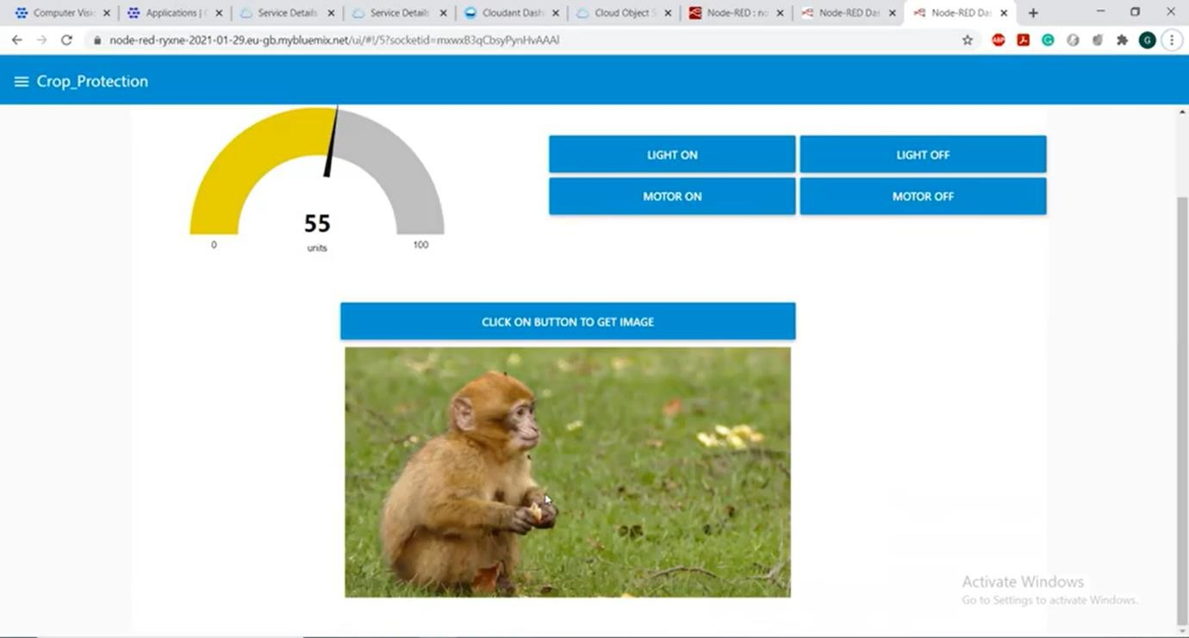

Thus we developed a web application using node-red service.